

Database Management Capstone report (ENCS205)

Bachelor of Technology in
Computer Science and Engineering

B. Tech CSE (Core) 4 Semester

School of Engineering & Technology

K. R. MANGALAM UNIVERSITY Sohna, Haryana 122103, India Jan-2026

Submitted By: | Submitted To:
Vanshika Dubey (2401010067) | MS. Mansi Kajal

CYBERSECURITY INCIDENT RESPONSE SYSTEM

1. Introduction
The Cybersecurity Incident Response System is a database-driven application designed to manage and analyze cybersecurity incidents. The system stores structured data related to events, alerts, vulnerabilities, and mitigation actions.
The main objective is to use Database Management System concepts to:
- Store cybersecurity data efficiently
- Maintain relationships between entities
- Perform queries for analysis and decision-making

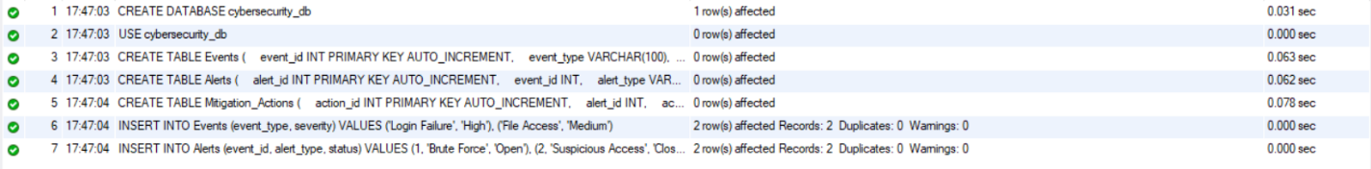

2. Objective of the Project
- To design a relational database for cybersecurity incidents
- To implement CRUD operations using SQL
- To analyze data using queries (risk, patterns, alerts)
- To demonstrate real-world DBMS application

3. Database Design
Entities Used
1. Events
Stores raw security logs/events
Attribute | Description
event_id (PK) | Unique ID
event_type | Type of event
severity | Risk level

2. Alerts
Generated from events
Attribute | Description
alert_id (PK) | Unique ID
event_id (FK) | Linked event
alert_type | Type of alert
status | Open / Closed

3. Mitigation_Actions
Stores response actions
Attribute | Description
action_id (PK) | Unique ID
alert_id (FK) | Related alert
action_taken | Description
status | Pending / Completed

Relationships
- One Event → Many Alerts
- One Alert → Many Actions

4. ER Diagram Explanation
- Events is a strong entity
- Alerts depend on Events → has foreign key
- Mitigation_Actions depends on Alerts
Weak Entity:
- Mitigation_Actions (depends on Alert)

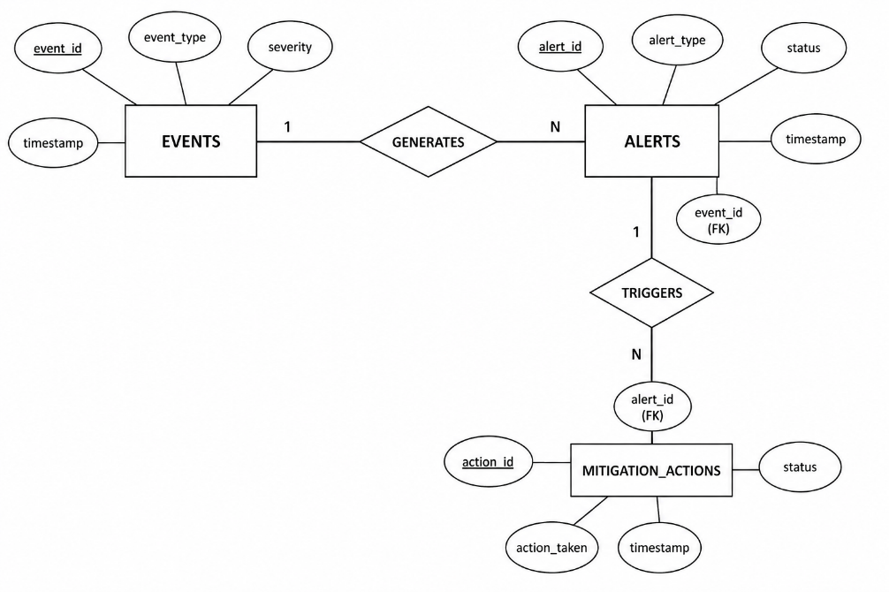

5. Normalization
Database is normalized to 3NF:
- No redundant data
- Proper foreign key relationships
- Data integrity maintained

6. SQL Operations (CRUD)
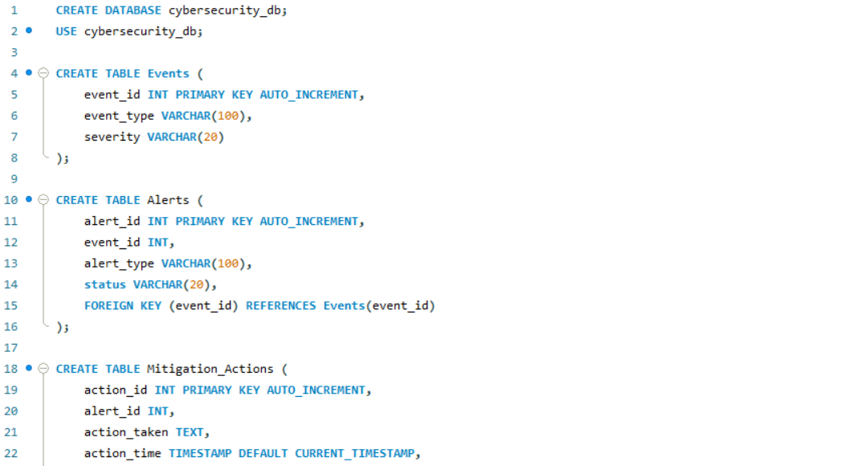
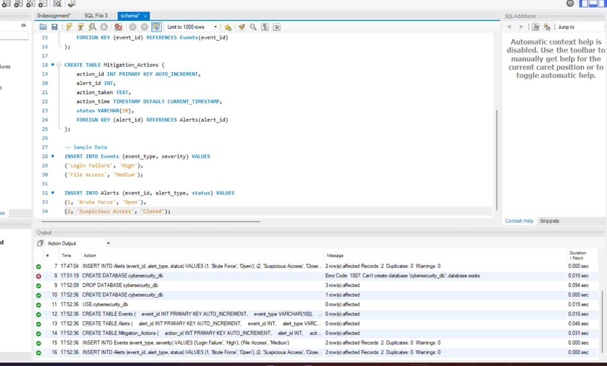

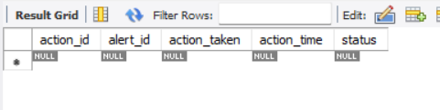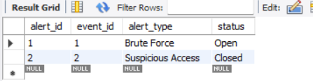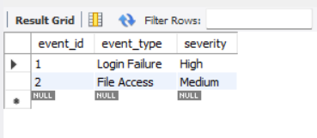

CREATE
INSERT INTO Events (event_type, severity)
VALUES ('Login Attempt', 'High');

READ
SELECT * FROM Alerts;

UPDATE
UPDATE Mitigation_Actions
SET status = 'Completed'
WHERE action_id = 1;

DELETE
DELETE FROM Events
WHERE event_id = 1;

Advanced Queries
Find High Severity Events
SELECT * FROM Events
WHERE severity = 'High';

Find Open Alerts
SELECT * FROM Alerts
WHERE status = 'Open';

Join Query (Event + Alert)
SELECT e.event_type, a.alert_type
FROM Events e
JOIN Alerts a ON e.event_id = a.event_id;

Risk Analysis
SELECT severity, COUNT(*)
FROM Events
GROUP BY severity;

8. Implementation
- Backend: Python (Flask)
- Database: MySQL
- Frontend: HTML, CSS, JavaScript
The frontend interacts with the database through API calls, enabling real-time data insertion and retrieval.

9. Features
- Event and alert storage
- Mitigation tracking
- Status updates
- Data visualization (dashboard)
- Relational database design

10. Conclusion
This project demonstrates how DBMS concepts can be applied to real-world cybersecurity problems. The system efficiently manages incident data using relational tables, foreign keys, and SQL queries.

11. Future Enhancements
- Add user authentication
- Implement real-time monitoring
- Add machine learning for threat detection
- Advanced analytics dashboard

